Ministry of education and science of Ukraine
National Technical University of Ukraine “Igor Sikorsky Kyiv Polytechnical Institute”
Educational and Scientific Institute
of Atomic and Thermal Energy

Department DCE

Calculation Graphical Work
credit module:
“Visualisation of graphical and geometrical information”

Done by:
student of 1-st course, ІАТЕ
group TR-42mp
Antonkin D.O
Verified by:
Demchyshin A.A
Kalenyk A.S

Kyiv– 2024
Task Description
Assignment presentation
- Share the link to your GIThub repo through the form.
- Make sure the repo contains a paper presenting your assignment
- The practical assignment has to reside in a branch named CGW.
Operations on texture coordinates
Scale and rotate a texture around a user specified point.

Requirements
- Reuse texture mapping from Control task.
- Implement texture scaling (texture coordinates) scaling / rotation around user specified point- odd variants implement scaling, even variants implement rotation
- It has to be possible to move the point along the surface (u,v) space using a keyboard. E.g. keys A and D move the point along u parameter and keys W and S move the point along v parameter.
Report
Prepare a digital report that holds:
- a title page;
- a chapter describing the task (1 page);
- a chapter describing theory (2 pages);
- a chapter describing the implementation details (2 pages);
- a chapter of user's instruction with screenshots (2 pages);
- a sample of source code (2 pages).

Theoretical information about scaling in WebGL
Texture Scaling in Computer Graphics
Texture scaling is a transformation that changes the size of a texture as it is applied to a surface. In WebGL, this process is implemented by modifying texture coordinates (UV coordinates), which map the texture to the object's geometry.

What Are UV Coordinates?
UV coordinates are a two-dimensional coordinate system where:
- U represents the horizontal axis,
- V represents the vertical axis.
UV coordinates typically range from [0, 1] on both axes. The value (0, 0) corresponds to the upper-left corner of the texture, while (1, 1) represents the bottom-right corner. Texture scaling is achieved by altering these coordinates before passing them to the shaders.

How Does Texture Scaling Work?
Multiplying Coordinates by a Scaling Factor:
- When UV coordinates are multiplied by a value greater than 1, the texture compresses (shrinks).
- When UV coordinates are multiplied by a value less than 1, the texture stretches (enlarges).
- Example: To enlarge a texture by 2x:
  - The UV coordinates are multiplied by a scaling factor of 0.5, effectively increasing the visible area of the texture.

Texture Transformation Matrix
Scaling is part of affine transformations that can be performed using a 3x3 matrix. The scaling transformation uses a matrix of the following form:
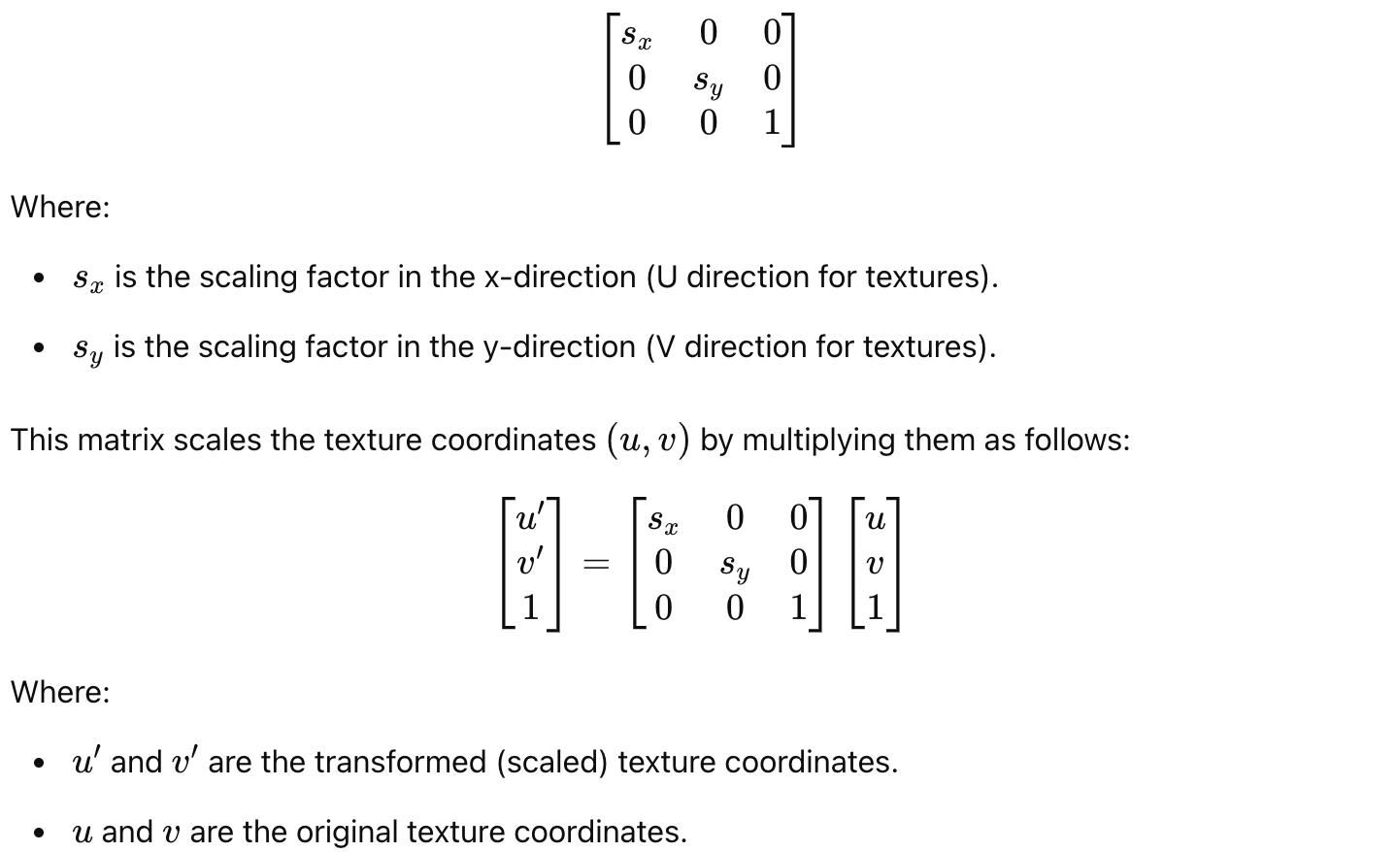

Dynamic Scale Control
Using uniform parameters in shaders allows textures to be scaled dynamically in real time, responding to user actions or other events.

Types of Texture Transformations
Local Scaling:
  - Changes the texture scale within a specific surface region.
  - Used to create effects such as enlarging or shrinking a texture around a particular point.
Global Scaling:
  - Uniformly applies scaling to the entire texture.
  - Used to control the level of texture detail.

Features of Texture Scaling
Texture Wrapping:
When texture scaling causes UV coordinates to exceed the [0, 1] range, WebGL applies wrapping modes:
  - REPEAT: The texture repeats.
  - CLAMP_TO_EDGE: The edge of the texture is stretched.
  - MIRRORED_REPEAT: The texture repeats in a mirrored pattern.
Texel Sampling:
Scaling may cause artifacts due to the limited resolution of the texture. To address this:
  - Mipmap generation: Creates reduced-resolution copies of the texture.
  - Filtering (Linear or Nearest): Smooths the texture to avoid pixelation.

Advantages and Disadvantages of Texture Scaling

Advantages
- Efficiency: Reducing texture size saves memory and computational resources.
- Detailing: Enlarging a texture can enhance the quality of graphics in small areas.

Disadvantages
- Artifacts: Incorrect scaling can distort or blur the texture.
- Memory Demands: Enlarging textures requires more resources.

Applications of Texture Scaling
Gradients and Details:
  - For example, creating materials like wood or marble, where local scaling adds realism.
Animation:
  - Time-based texture scaling is used for effects like waves, expanding rings, or object enlargement.
Games and Virtual Reality:
  - Optimizes textures for large surfaces or enhances detail in critical areas.
Implementation details
Texture scaling in the project is implemented by modifying texture coordinates based on the position of a point on the surface and the specified scale. Below are the main stages and the mechanism of the scaling implementation:

1. Core Concept of Scaling
The texture scale depends on the distance between the current surface point and a specified point (uPointPosition). The closer the surface point is to uPointPosition, the more the texture scale changes.

2. Key Components of the Implementation
- uPointPosition: Passes the coordinates of the point around which scaling is applied.
- uScaleFactor: Passes the scale factor that controls the intensity of texture modification.

Vertex Shader
In the vertex shader, texture coordinates are modified based on:
- The distance between the current vertex (aPosition) and the point uPointPosition.
- The specified scale factor uScaleFactor.
Code in the vertex shader:
float distance = length(aPosition - uPointPosition);
vTexCoord = aTexCoord * (1.0 + uScaleFactor * distance);
Here:
- distance calculates the distance between the current vertex and uPointPosition.
- vTexCoord contains the modified texture coordinates.
The larger the distance, the greater the impact of uScaleFactor on the texture coordinates.

3. Passing Data to Shaders
The updatePointPosition function computes the position of the specified point based on pointU and pointV. It also updates the corresponding uniform parameters:
- uPointPositionLoc — coordinates of the point.
- uScaleFactorLoc — scale factor.
Code:
const pointPosition = surface.uLines[uIndex][vIndex];
const scaleFactor = scaleSlider.value;

gl.uniform3fv(shProgram.uPointPositionLoc, pointPosition);
gl.uniform1f(shProgram.uScaleFactorLoc, scaleFactor);

4. Final Result in the Fragment Shader
The fragment shader uses the modified texture coordinates (vTexCoord) to fetch the texture data. This results in texture scaling based on the distance from the specified point.
Code:
vec3 diffuseMap = texture2D(uDiffuseTexture, vTexCoord).rgb;

5. Interface Controls
The user can adjust:
- Point position (pointU, pointV) using the W, A, S, D keys.
- Texture scale (uScaleFactor) using a scaleSlider.
The updatePointPosition function automatically updates the texture scaling whenever parameters are modified.

User instructions
To run the application, you need to have the Git version control system installed and execute a simple command in the terminal:
git clone https://github.com/toshytwx/WebGL.git
Next, you need to switch to the branch in the repository where the coursework is implemented by executing the following command:
git switch -c cgw origin/cgw
After these steps, it is recommended to open the coursework project in a convenient code editor. The best option would be VSCode, as it has a sufficient number of extensions and plugins for working with code.
After opening the project in VSCode, to successfully run the program locally, you need to install the additional LiveServer plugin. This plugin encapsulates the mechanics and logic of a local HTTP server, which is done to bypass the Cross-origin policy of many modern browsers, specifically the inability to use and deploy third-party resources in web applications.
To install the plugin, go to the Extensions tab, type "LiveServer" in the search field, and install the extension as shown in the screenshot:

Next, you need to return to the project files, find the index.html file, right-click on it, and select the “Open with Live Server” option from the context menu. The task should automatically open in the default browser, and the browser window should look like this:
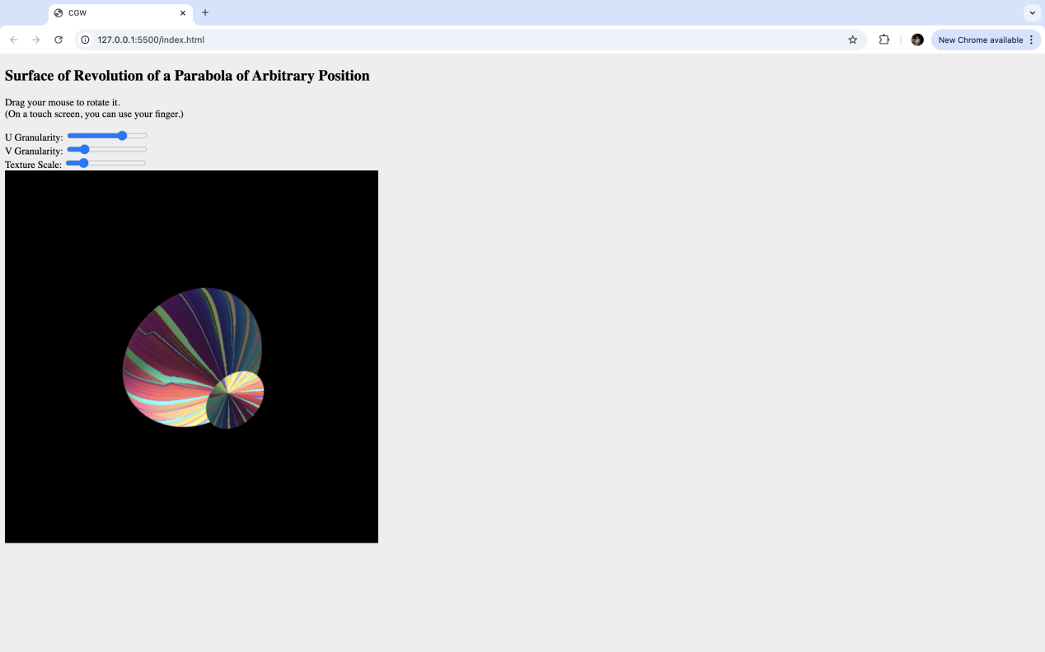
The user has the ability to change 3 surface parameters, thereby altering its appearance, namely:
- Changing the scaling parameters, i.e., the texture scaling coefficient;
- Changing the granularity of U and V lines, i.e., adjusting the number of polygons on the surface.
Additionally, the user can change the surface's tilt angle by holding the left mouse button (LMB) and moving the cursor with the mouse or trackpad.
Similarly, the W, A, S, D keys on the keyboard are interactive, and when pressed, the user can change the position of the point on the surface, around which texture scaling occurs.
By adjusting all or some of these parameters, the following result can be achieved:
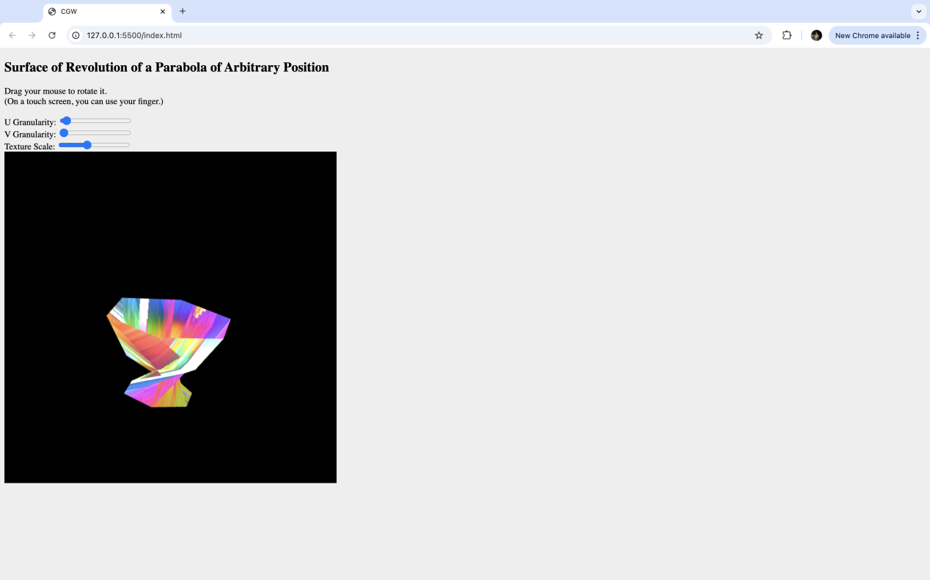

Code samples
precision highp float;

varying vec3 vColor;
varying vec2 vTexCoord;
varying vec3 vTangent;
varying vec3 vBitangent;
varying vec3 vNormal;

uniform sampler2D uDiffuseTexture;
uniform sampler2D uSpecularTexture;
uniform sampler2D uNormalTexture;
uniform vec3 uLightDirection;

void main() {
vec3 diffuseMap = texture2D(uDiffuseTexture, vTexCoord).rgb;
vec3 specularMap = texture2D(uSpecularTexture, vTexCoord).rgb;
vec3 normalMap = texture2D(uNormalTexture, vTexCoord).rgb;

normalMap = normalize(normalMap * 2.0 - 1.0);
mat3 TBN = mat3(vTangent, vBitangent, vNormal);
vec3 normal = normalize(TBN * normalMap);

vec3 finalColor = diffuseMap + specularMap + normal;

gl_FragColor = vec4(finalColor * vColor, 1.0);
}

attribute vec3 aPosition;
attribute vec3 aNormal;
attribute vec2 aTexCoord;
attribute vec3 aTangent;

uniform mat4 uModelViewMatrix;
uniform mat4 uProjectionMatrix;
uniform mat4 uNormalMatrix;
uniform vec3 uLightDirection;

uniform vec3 uViewPosition;
uniform vec3 uAmbientColor;
uniform vec3 uDiffuseColor;
uniform vec3 uSpecularColor;
uniform float uShininess;

uniform vec3 uPointPosition;
uniform float uScaleFactor;

varying vec3 vColor;
varying vec2 vTexCoord;
varying vec3 vTangent;
varying vec3 vBitangent;
varying vec3 vNormal;

void main() {
vec3 transformedNormal = normalize((uNormalMatrix * vec4(aNormal, 0.0)).xyz);
vec3 tangent = normalize(aTangent);
vec3 bitangent = cross(transformedNormal, tangent);

tangent = normalize(tangent - dot(tangent, transformedNormal) * transformedNormal);
bitangent = normalize(bitangent - dot(bitangent, transformedNormal) * transformedNormal);

vTangent = tangent;
vBitangent = bitangent;
vNormal = transformedNormal;
vec3 fragPosition = (uModelViewMatrix * vec4(aPosition, 1.0)).xyz;
vec3 lightDir = normalize(uLightDirection - fragPosition);
vec3 viewDir = normalize(uViewPosition - fragPosition);

vec3 ambient = uAmbientColor;
float diff = max(dot(transformedNormal, lightDir), 0.0);
vec3 diffuse = uDiffuseColor * diff;

vec3 reflectDir = reflect(-lightDir, transformedNormal);
float spec = pow(max(dot(viewDir, reflectDir), 0.0), uShininess);
vec3 specular = uSpecularColor * spec;

vColor = (ambient + diffuse + specular);
float distance = length(aPosition - uPointPosition);
vTexCoord = aTexCoord * (1.0 + uScaleFactor * distance);

gl_Position = uProjectionMatrix * uModelViewMatrix * vec4(aPosition, 1.0);
}

